One third of Kickstarter projects have made it through the funding process with a positive outcome, the objective of this analysis is to review a sample of the that and conclude the chances of having a successful campaign. What makes a campaign a good candidate to be successful, and making a decision based on our results.

This is sample data taken out of Kickstarter database, from 5/17/2009 to 3/15/2017 showing a brief description of the campaign, goal, time frame, and category among other data points.

There are many conclusions that we can take out of this data. Some of it obvious, like the lower the goal, the more chances of having a successful campaign or summertime increases the chances of a successful campaign over wintertime, that reduces the chances.

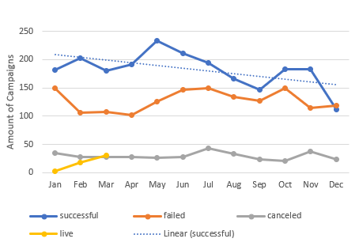

Getting a deeper analysis, we can find that there are 6% of outliers that pledged much more than the goal. Specifically, 258 that surpass 200%. Also, on the first years it was easier to have successful campaign and each year it becomes more of a challenge, there are more failed campaigns.

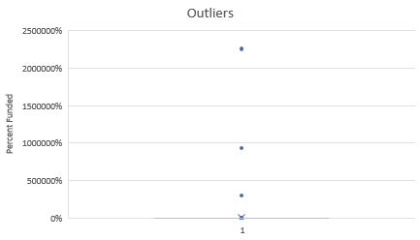

Having a lower goal or having a Theater campaign increases the chances of a successful Campaign.

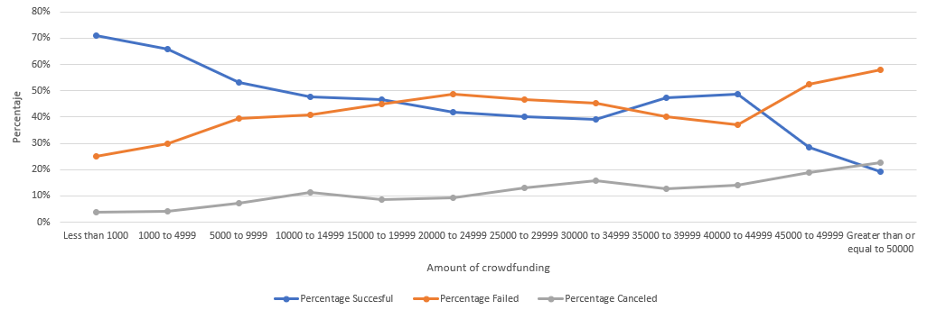

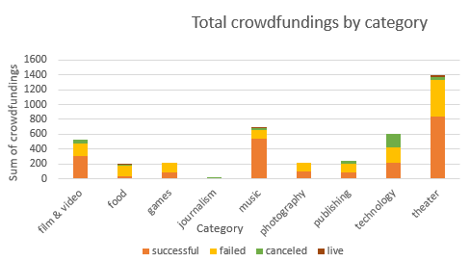

Some recommendations and limitations of this data are that It is not defined if the goal of a campaign is realistic, conservative or too aggressive. Without knowing that, it is an assumption to conclude that the ratio of goal and pledge, accurately measures the success of campaigns. It is very important to define what makes a campaign successful or not. I consider more successful a campaign that got 99% of its goal, when this goal is over $2,000.00 than a campaign that successfully reached its goal, when the goal was for $1.00.

Also, We know this data is a sample from 5/17/2009 to 3/15/2017 and some campaign haven’t pledge anything, it doesn’t specify if this is because a campaign is new or is it because it got canceled just after its beginning or if simply didn’t get any donation.

Some other interesting conclusions are that, almost 30% of Successful campaigns were Staff Picks, compared to 1% Cancelled and 5% Failed, this concludes that if a campaign is Pick by the Staff it has a higher chance of success.

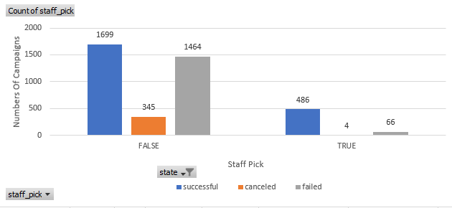

Most of successful campaigns had a duration of 30 days.

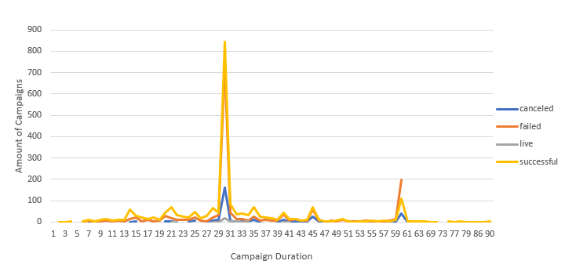

Although this data makes good points and shows conclusions with arguments, I think using another set of data sample or even a complete data is necessary to see the big picture, this work needs more data to be able to make a decision.